**Analyzing Olympic Data with Power BI**

In this project, we explore how to analyze a large dataset of Olympic data with Power BI. We walk through the process of uploading the dataset, exploring its relationships, and analyzing the data for insights.

**by Deepak Kumar**

**The Power of Data Modeling in Power BI**

Data modeling is a critical step in analyzing large datasets. In this project, we use Power BI's data model view to organize and visualize the relationships between all 11 csv files. This powerful tool allows us to see all of the data in one place and to extract deeper insights.

**Streamlined Approach -**

**The data model view provides a streamlined approach to organizing complex data structures, making analysis more efficient and accurate.**

**Visual Representation -**

**The data model is represented visually, which makes it easy to understand the relationships between the tables.**

**Easy To Navigate -**

**This tool is user-friendly and makes it easy to navigate through complex relationships within datasets.**

**Uploading Data in Power BI – To upload the data, navigate to the "Get Data" tab and select "Text/CSV". Then, select the csv file you want to upload.**

**Exploring the Relationship Between the Tables**

**Understanding the relationship between tables is the key to unlocking insights in complex data. In this project, we explore the relationships within the Olympic data tables.**

|  |  |
| --- | --- |
| **Table Name** | **Relation with other tables** |
| **City** | **Has a one-to-many relationship to "games" and one-to-one to the "games competitor" table** |
| **Event** | **Has a one-to-many relationship with the "games" table and a many-to-many relationship with the "sports" table.** |
| **Game** | **Has a one-to-many relationship with the "games competitor" table and a one-to-many relationship with the "medals" table.** |
| **Game Competitor** | **Has a one-to-many relationship with the "medals" table and a many-to-one relationship with the "athlete" table.** |
| **Sports** | **Has a many-to-many relationship with the "events" table.** |
| **Medals** | **Has a many-to-one relationship with the "games" table and a many-to-one relationship with the "games competitor" table.** |

**Besides these we do also have many other columns which I will be discussing further.**

**Identifying the Lack of Organized Relationship –**

**Before we can analyze data, we must identify the lack of organized relationships between tables. In this project, we identify and explore the lack of organized relationships within the Olympic data tables.**

**3 Resolution**

By understanding the relationships, we were able to build a data model and perform more advanced analysis.

**2 Identifying the Issue**

The data modeling view helped us to identify the problem and visualize the relationships between the tables.

**1 No Clear Relationship**

The Olympic data tables had no clear, organized relationships, making it difficult to perform in-depth analysis.

**Power BI's Strengths –**

**Power BI is an essential tool for understanding complex datasets. By using the tools discussed in this project, including data modeling and data visualization, we can uncover deeper insights and improve decision-making.**

**Merging Tables: Exploring Games, Events, and People –**

**A comprehensive table merging Competitor, Games City, City, and Games data. -**

**Competitor ID, Game ID, Person ID, Age, City ID, City Name, Game Year, Game Name, Session.**

**Event Table: Unveiling the Link between Competitor, Event, Medal, and Sports. –**

**Competitor id, Event id, Medal id, and Sports id, Event Name, Medal Name, Sport Name.**

**Person Table: Connecting Noc Region, Person, and Person Region**

**Region ID, NOC, Region Name, Person ID Person Name, Person Gender, Height, Weight.**

**Explanation of the Table Merges**

**Games Table - The Games Table merges Competitor ID, Game ID, Person ID, Age, City ID, City Name, Game Year, Game Name and Session providing a comprehensive overview of competitors and the cities where games take place.**

**Event Table - The Event Table links Competitor id, Event id, Medal id, and Sports id, Event Name, Medal Name and Sport Name allowing in-depth analysis of competitors' performance in various events.**

**Person Table - The Person Table connects Region ID, NOC, Region Name, Person ID Person Name, Person Gender, Height and Weight.** 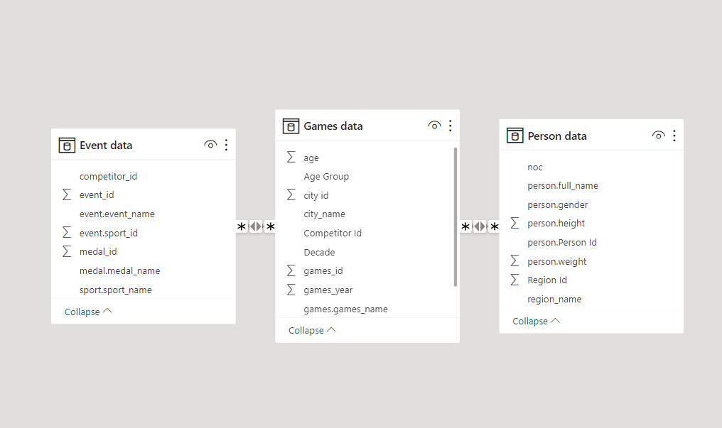

**Now we can start answering the questions**

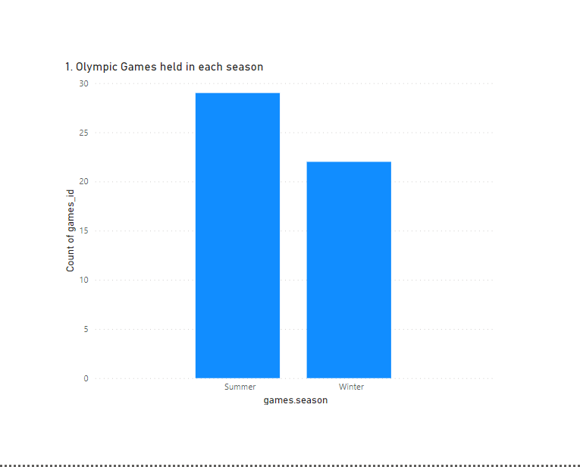**After analysing the data after merging all the tables into three main tables we can start answering all the question quickly and effectively.**

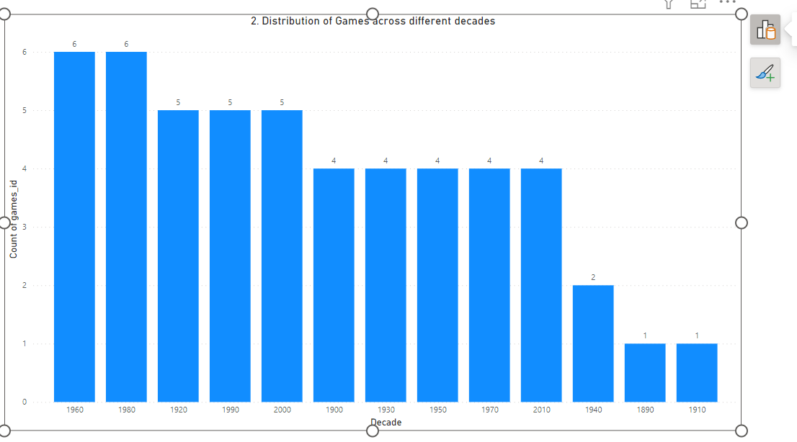

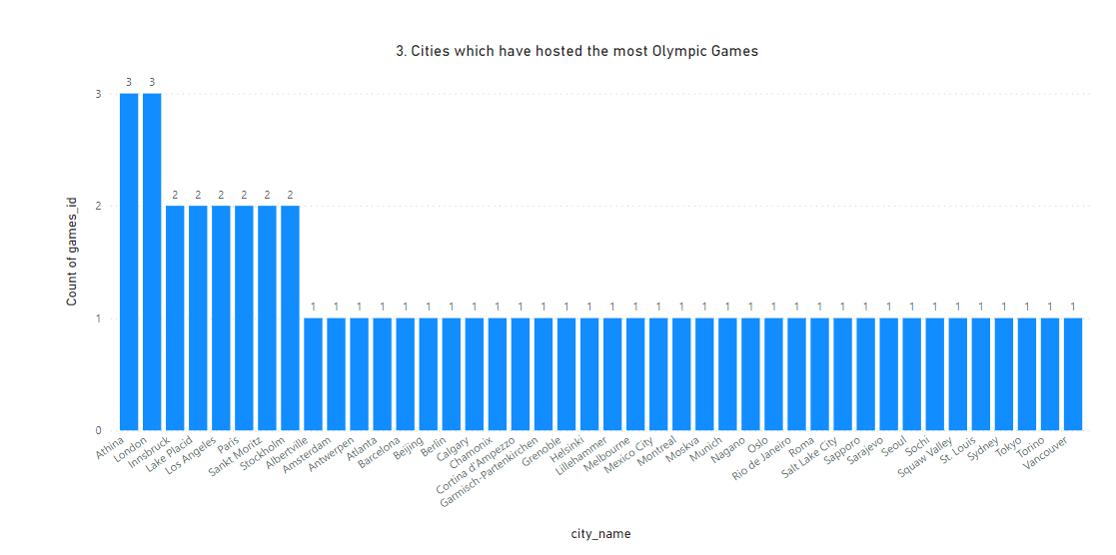

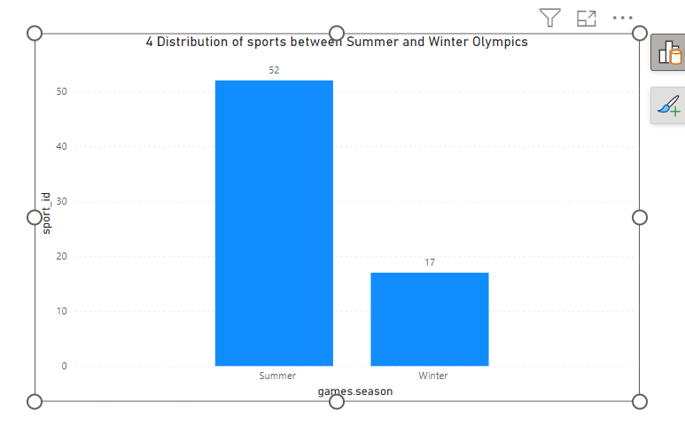

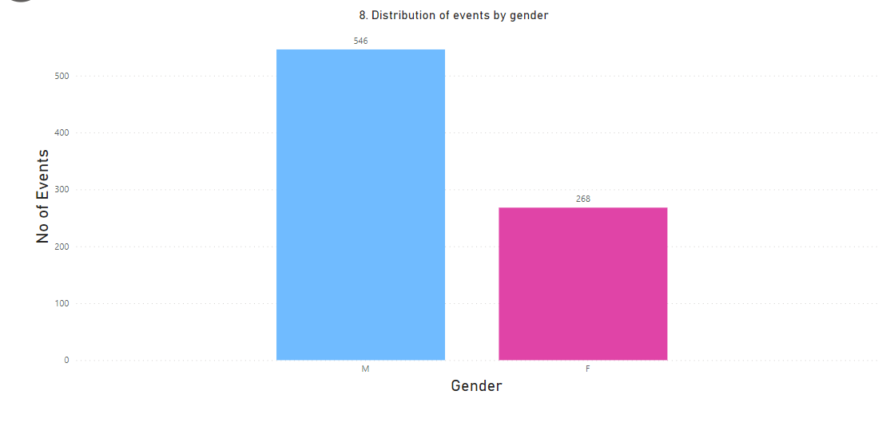

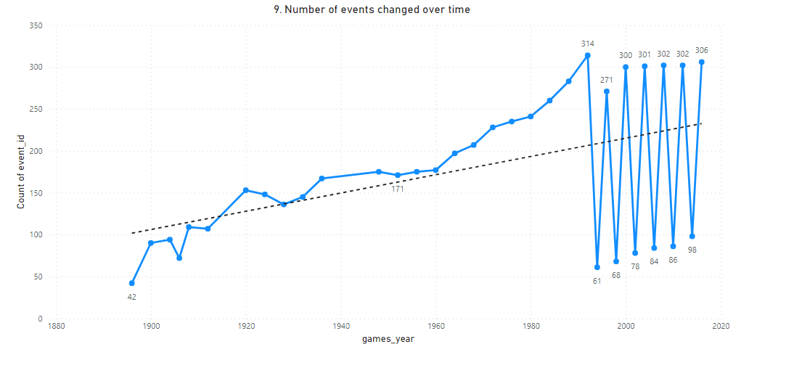

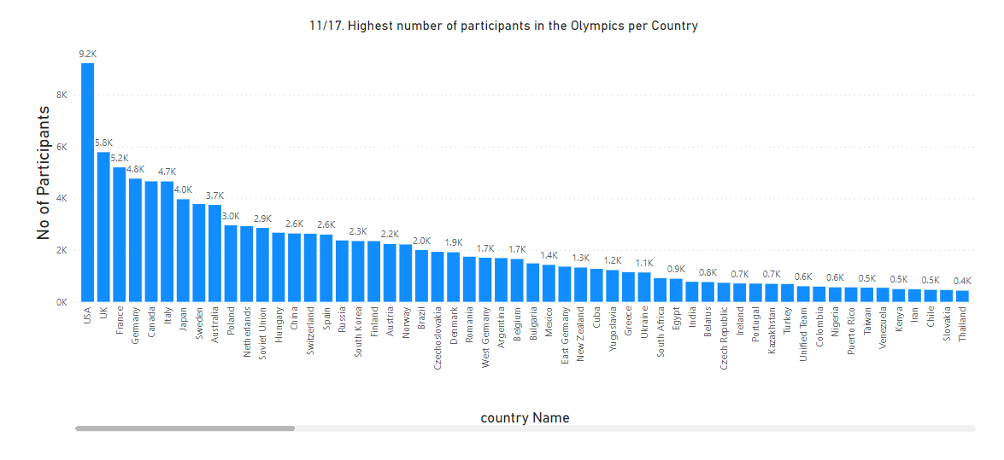

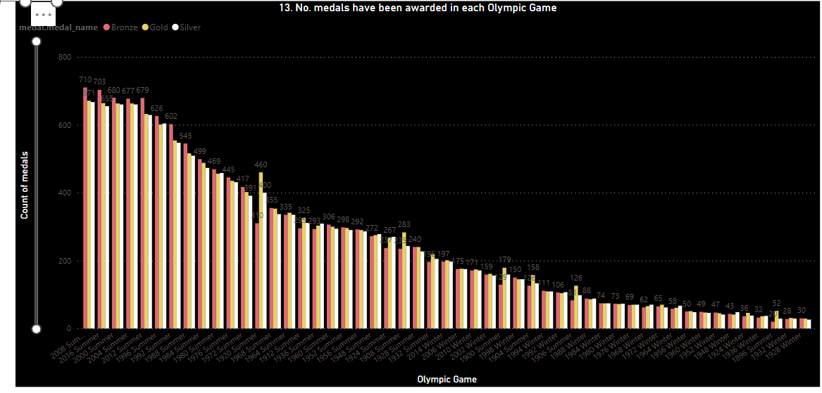

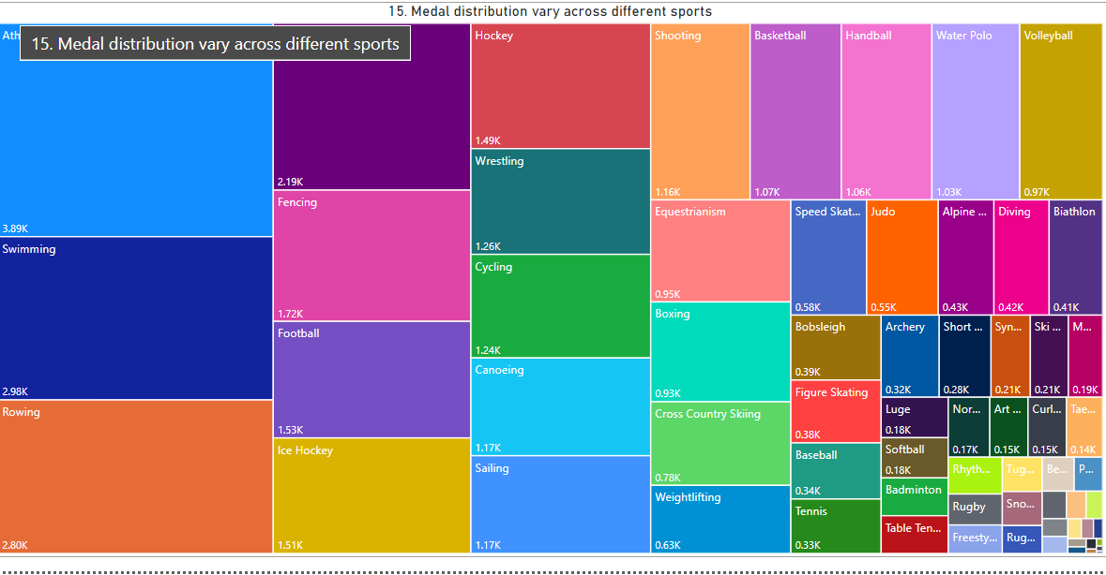

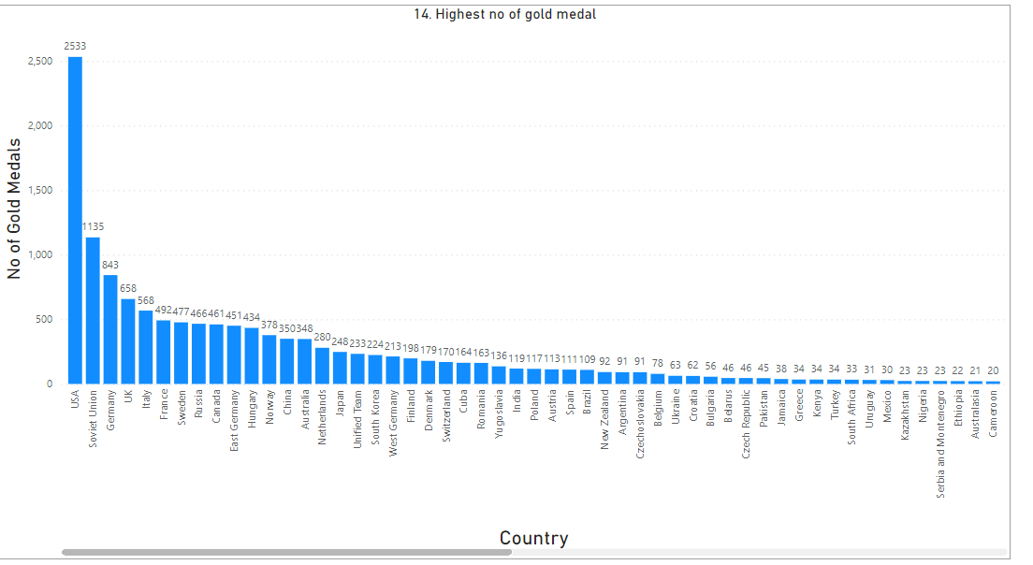

**Conclusion**

**By merging tables using a Fuller Outer Join, we have unlocked valuable insights from the Games Table, Event Table, and Person Table. These merged tables provide a deeper understanding of the connections between competitors, events, medals, cities, regions, and sports. Whether it's analyzing competitors' performance or studying the geographical distribution of games, table merging enhances our ability to interpret and utilize data effectively.**